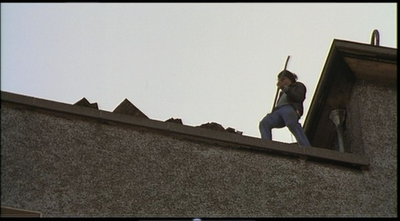

Visual Techniques: Oral Techniques:

How it introduces the character:

Visual Techniques: Oral Techniques:

How it introduces the character:

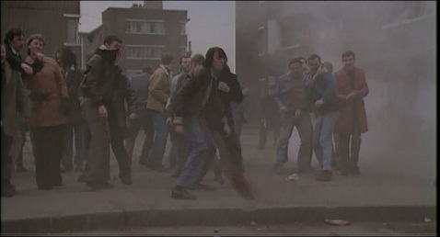

Visual Techniques: Oral Techniques:

How it introduces the character:

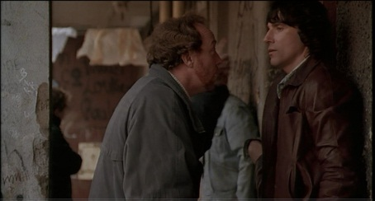

Visual Techniques: Oral Techniques:

How it introduces the character:

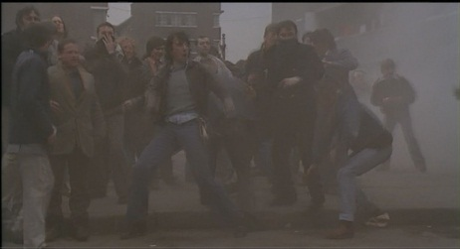

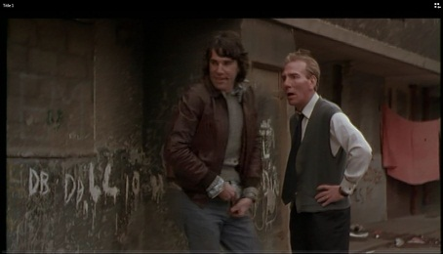

Visual Techniques: Oral Techniques:

How it introduces the character:

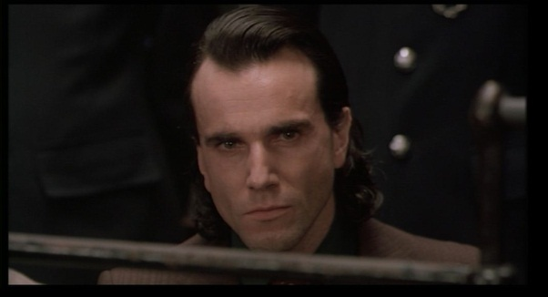

Visual Techniques: Oral Techniques:

How this shows change in character:

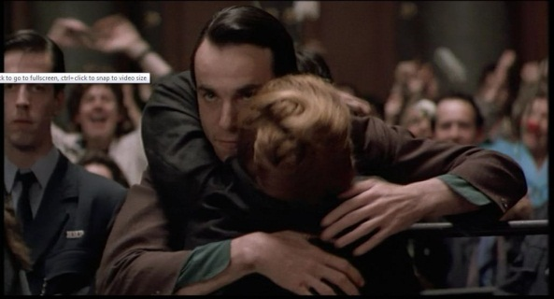

Visual Techniques: Oral Techniques:

How this shows change in character:

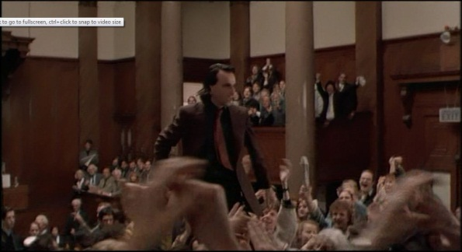

Visual Techniques: Oral Techniques:

How this shows change in character:



Visual Techniques: Oral Techniques:

How this shows change in character: